**CPSC 6157 Network & Cloud Management**

**Spring 2025**

**Hands-on Exercise 10**

**Amazon AWS CloudWatch**

**Due by 11:30 PM Monday, April 7**

**Instructions: Please submit a single PDF or Word document that contains all the answers and screenshots to CougarView.**

**Part I**. **(10%)** Watch the YouTube video about the differences between AWS CloudWatch and CloudTrail through the link below:

[AWS Cloudwatch vs Cloudtrail - Whats the Difference?](https://www.youtube.com/watch?v=S5X0PnBwp9I)

Conduct research and write a detailed summary below **with at least 200 words** about the **Amazon AWS CloudWatch** (available under category “Management & Governance” on Amazon AWS). You may write the summary by answering the following questions:

1. What is the Amazon AWS CloudWatch?
   * It is a service that allows collection, monitoring, and analyzing application metrics.
2. What is the AWS CloudWatch monitoring service used for?
   * It’s used to log app data and create monitoring tools based on certain metrics such as resource utilization, etc. and create alarms for certain scenarios. Furthermore, it can be used to run analytics on those metrics and query certain data to generate custom dashboards.

**Part II**. **(30%)** Create a **12-Months-Free tier Amazon AWS account** through the link:

<https://aws.amazon.com/free/?all-free-tier.sort-by=item.additionalFields.SortRank&all-free-tier.sort-order=asc>

* Make sure the following items are checked under the Tier Type and Product Categories before your AWS account is created.

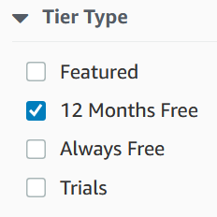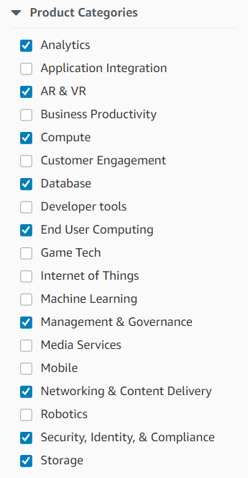

* The 12-Months-Free tier accounts are only available to NEW AWS customers. However, it requires you to set up an AWS account with payment information. You will need to pay attention as it does charge you if the services you subscribed use resources ***over the “default” limit***, which in some cases is true. That’s why you will need to setup an alarm in billing (this is a part of the work for this exercise). When the dollar amount reached to the threshold (for example, **$5**), you’ll receive an email or SMS and take actions by stopping or removing the AWS services. Therefore, if you already have an existing Amazon AWS account, ***you need to use a NEW e-mail and create a NEW AWS account for this course using the username***: ***YourLastName_FirstName_Fall2024***.

**What to submit for Part II?**

After your AWS account (***with*** ***the username***: ***YourLastName_FirstName_Fall2024***) is created, log into your account and then sign into the Console. Take a screenshot (similar to the one shown below) that contains your username at the top-right corner. This is evidence that your AWS account has been successfully created. Copy and paste the screenshot in this Word document below. This is the only screenshot you need to submit for **Part II**.

**Your full name MUST be shown in the username displayed here on the tool bar.**

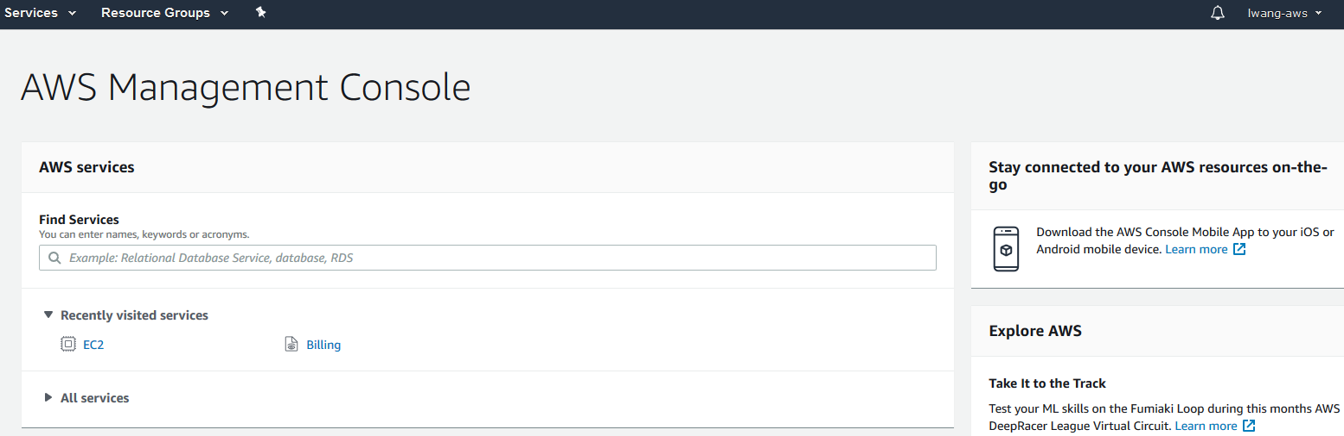

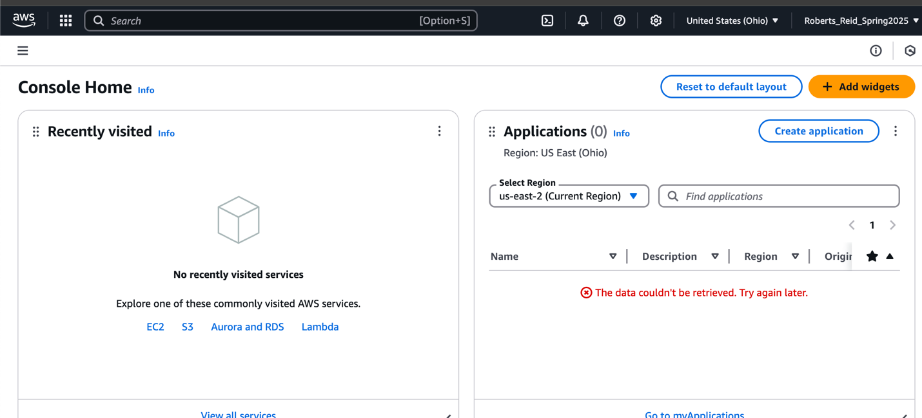

**Part III**. **(60%)**

1. (**20%**) Add **CloudWatch** to your AWS account (take a screenshot for it)

1. (**20%**) Setup **a billing dashboard** under CloudWatch to monitor the resources, such as CPI utilization, disk read/write, network in/out (take a screenshot for it)
   1. I’m not sure what to put on the dashboard since we don’t have any apps running yet so I just included some billing options AWS had available.

1. (**20%**) **Under billing dashboard, set up alarm so that AWS will send you an email or SMS *if your free usage cost exceeds $5*** (take a screenshot for it). You may follow the instructions provided in the YouTube video below:

[How to Create a CloudWatch Billing Alarm to Monitor AWS Charges?](https://www.youtube.com/watch?v=cHFhLUTqqEs)

**What to submit for Part III?**

Copy and paste all the screenshots in this Word document below. Do NOT upload the screenshots individually to CougarView.